Name: Sanio Luke Sebastian
Roll No: 35
Batch: B
Date: 06-05-2022

ADVANCED DBMS LAB

Experiment No.: 7

Aim
To familiarize with Group by and Having clause

Questions:

Using the lab cycle 06 database, perform the following queries.

- List the branches having sum of deposit more than 5000.
- List the branches having sum of deposit more than 500 and located in city BOMBAY
- List the names of customers having deposited in the branches where the average deposit is more than 5000.
- List the names of customers having maximum deposit
- List the name of branch having highest number of depositors?
- Count the number of depositors living in NAGPUR.
- Give names of customers in VRCE branch having more deposite than any other customer in same branch
- Give the names of branch where number of depositors is more than 5
- Give the names of cities in which the maximum number of branches are located
- Count the number of customers living in the city where branch is located

Procedure & Outputs

use lab_cycle_six;

- select d.bname from deposit d, branch b where d.bname=b.bname and b.city='Bombay' group by d.bname having sum(d.amount)>5000;
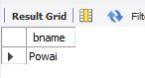

- select d.bname from deposit d, branch b where d.bname=b.bname group by d.bname having sum(d.amount)>5000;
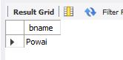

- select cname from deposit where amount=(select avg(amount) from deposit group by bname having avg(amount)>5000);
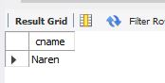

- select max(amount),cname from deposit;
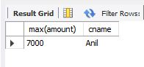

- select d1.bname from deposit d1 group by d1.bname having count(d1.cname) >= all (select count(d2.cname) from deposit d2 group by d2.bname);
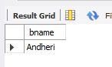

- select count(deposit.cname)from deposit,customer where customer.city='Nagpur';
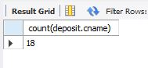

- select cname from deposit where bname='VRCE' and amount=(select max(amount) from deposit where bname='VRCE');
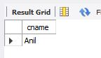

- select bname from deposit group by bname having count(bname) > 5;
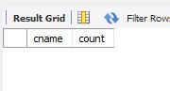

- select c.cname ,count(b.bname) as count from customer c inner join branch b on c.cname=b.bname group by c.cname order by count(b.bname) desc;


- select count(b1.bname) from deposit d1 , borrow b1 , customer c1 where c1.cname=d1.cname and d1.cname=b1.cname and c1.city in (select city from customer);
